MCA NEP I JAN 2026 ADBMS LAB
SEAT NO.: 2013748

Q1) Create a table Staff with attributes Staff with attributes Staff_ID, Full_Name, Experience, Pay_Scale and Hire_Date using HASH partitioning on the Pay_Scale field.

Create table with 3 partitions (S1,S2,S3)

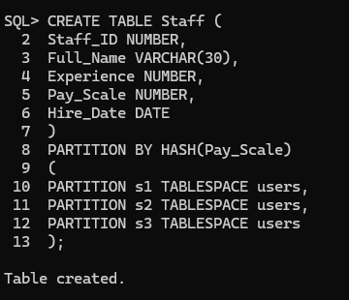

Inserting 10 Records inside the Staff Table

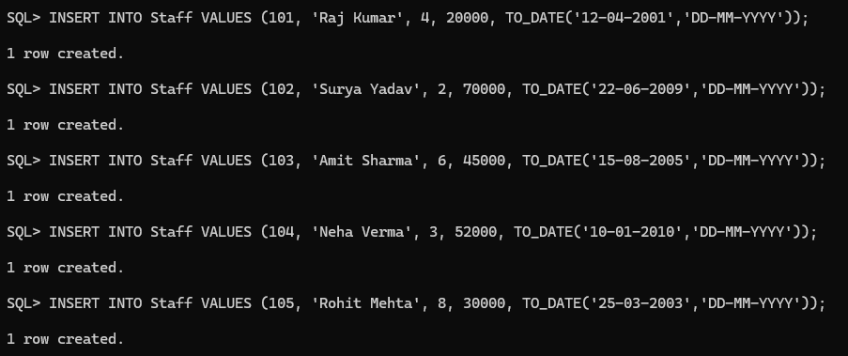

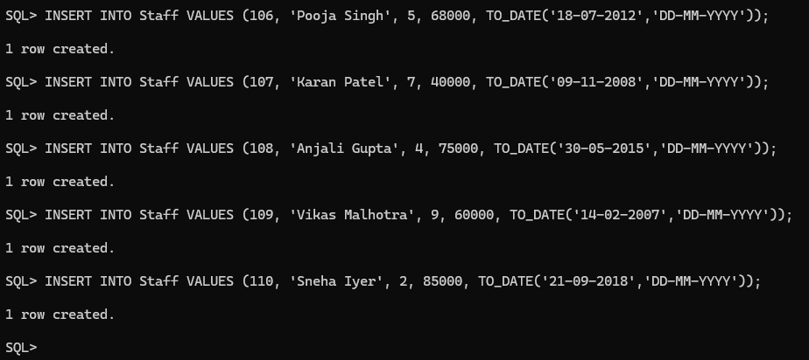

Display all the Records
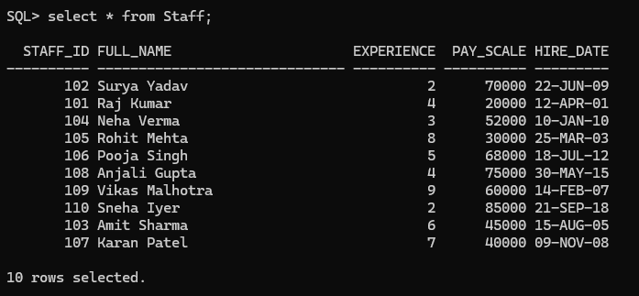

Display Partitions-wise records

S1
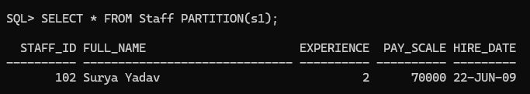

S2
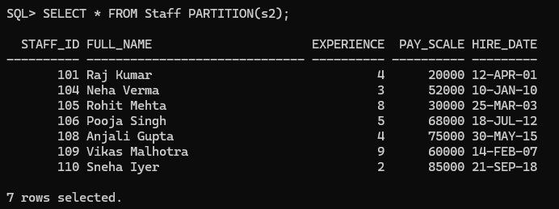

S3
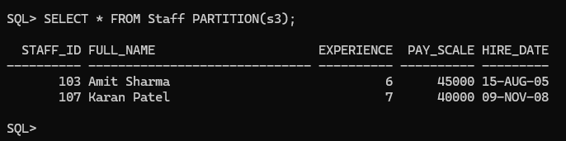

Q2) Implement K-means algorithms for 3 clusters in R programming using Iris dataset.

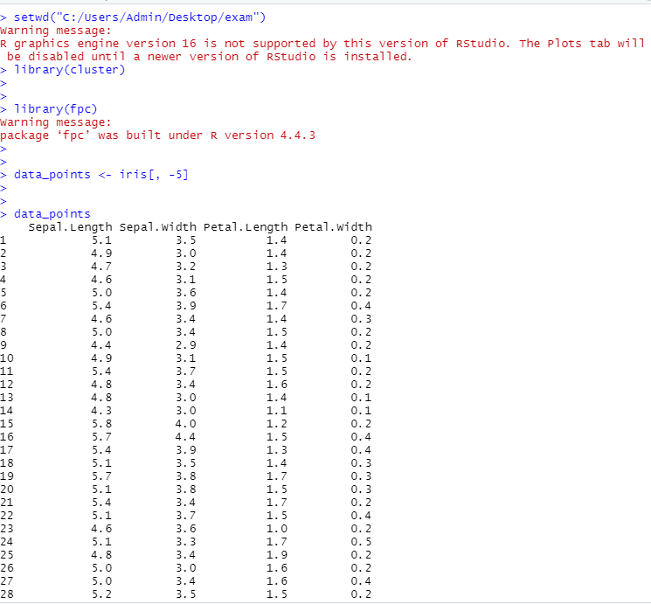

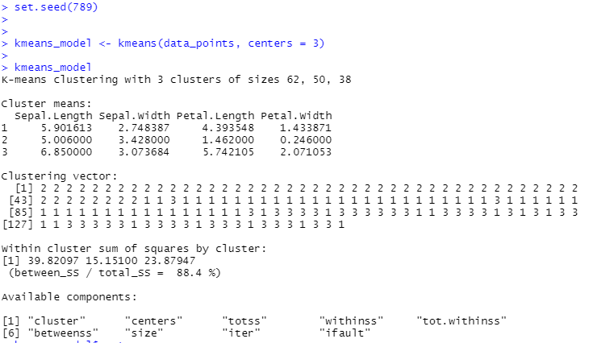

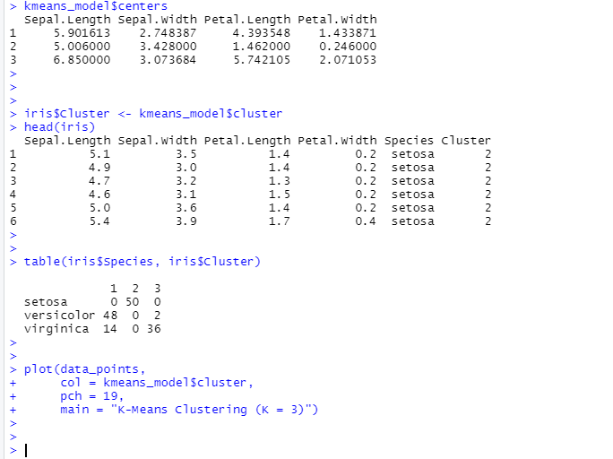

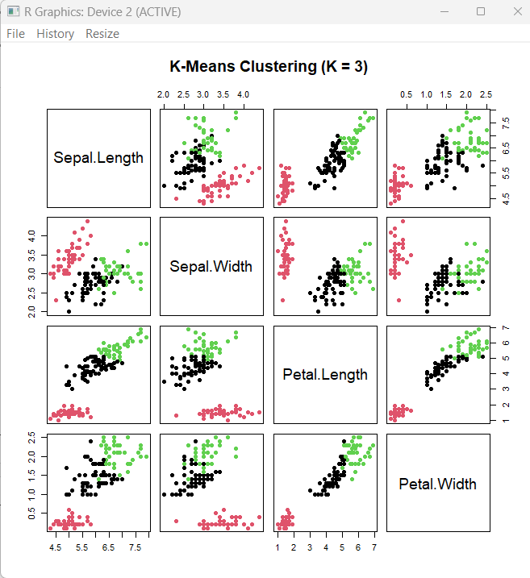

Q3) Create Table EMP in oracle having field Emp_no, Emp_name, salary, city

- Create table in Oracle SQL and inserting 5 records
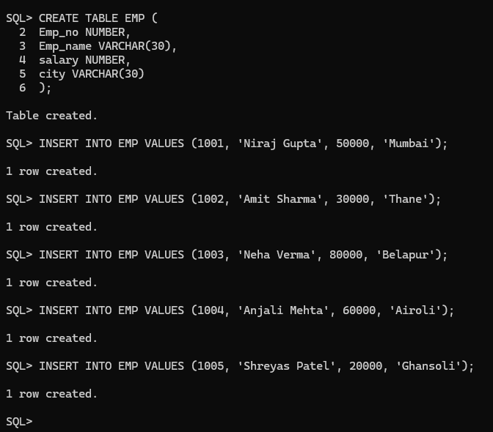

Command to get the Database name for connection

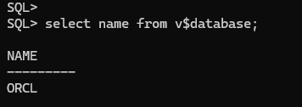

Connecting the Database

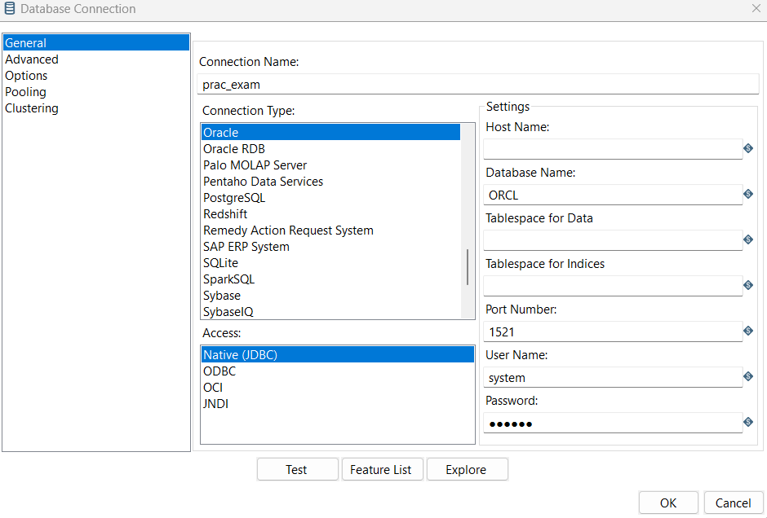

Database connected
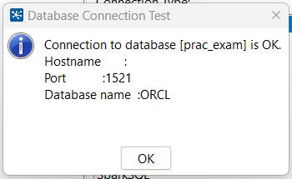

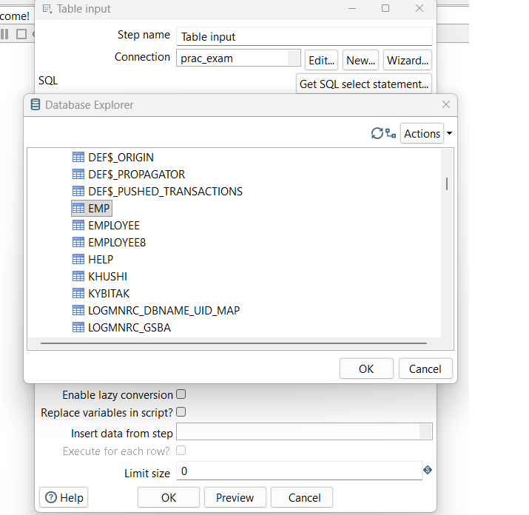

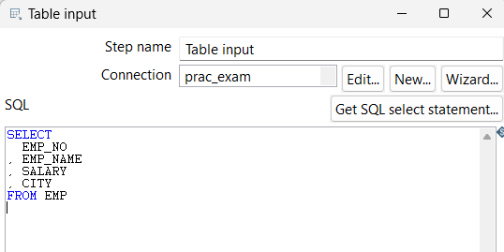

- Fetch this table in Pentaho

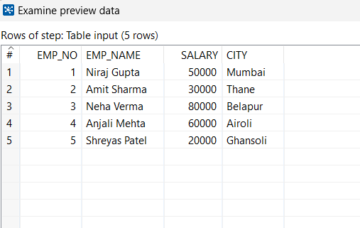

- Apply Sort function city column in descending order

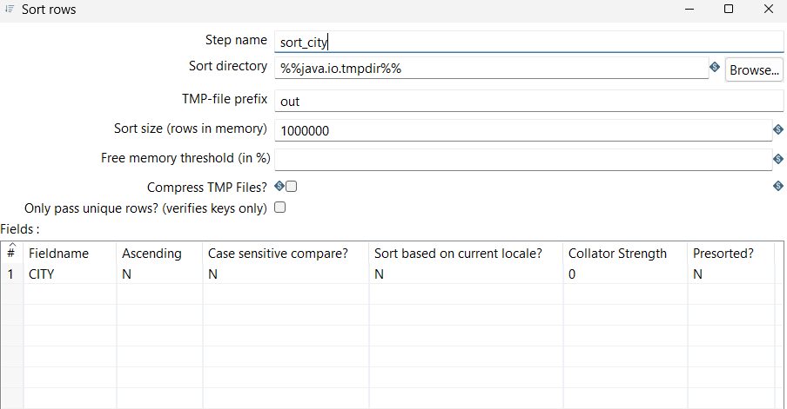

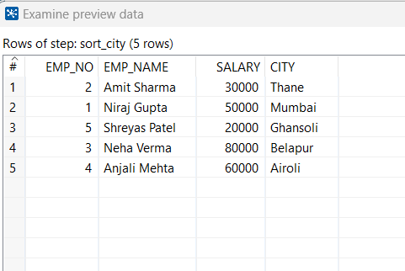

- Create target table which contain only Emp_no and city
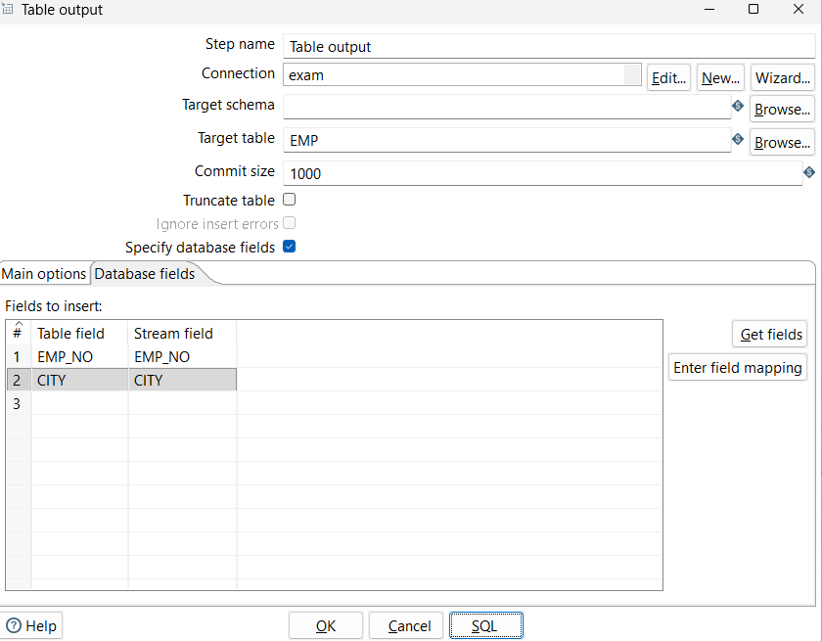

- Reflect the changes in SQL

